

**A project report on**

**"Face Recognition Attendance System”**

**Submitted in partial fulfillment of the requirement for the award of**

**DIPLOMA IN**

**Computer Engineering**

**by**

**Amisha Pupala**

**Mokshada Godase**

**Pratiksha Kharatkar**

**Pratiksha Batwal**

**Under the guidance of**

**Prof. Mayur Bhosale**

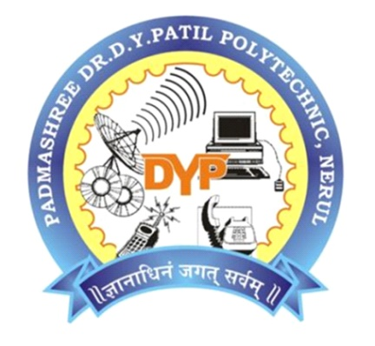

**DEPARTMENT OF COMPUTER ENGINEERING**

**DR. D. Y. PATIL POLYTECHNIC**

**Dr. D. Y. Patil Vidyanagar, Sector-7, Nerul, Navi Mumbai – 400706**

**Academic Year 2017 – 2018**

**CERTIFICATE**

**This is to certify that the report on project entitled**

**"Face Recognition Attendance System”**

**has been successfully completed and submitted by**

**NAME ROLL NO SEATNO**

Amisha Pupala 48 (_________)

Mokshada Godase 34 (_________)

Pratiksha Kharatkar 44 (_________)

Pratiksha Batwal 40 (_________)

for the partial fulfillment of the requirement for the award of Diploma Course in Computer Engineering as laid down by **Maharashtra State Board of Technical Education** for the academic year **2017 – 2018.**

**During the project they have maintained regular attendance and have worked sincerely.**

**(_______________) (_______________) (_______________) (Prof. M. Bhosale) (Prof. U. Patil) (Prof. S.G. Pathak)**

**PROJECT GUIDE H.O.D PRINCIPAL**

**(_______________) (_______________)**

**INTERNAL EXAMINER EXTERNAL EXAMINER**

**INDEX**

|  |  |  |
| --- | --- | --- |
| **SR NO** | **NAME** | **PAGE NO** |
| 01 | ABSTRACT | 1 |
| 02 | INTRODUCTION | 2 |
| 03 | LITERATURE SURVEY | 3 |
| 04 | PROBLEM DEFINITION | 8 |
| 05 | PROPOSED SYSTEM | 9 |
| 06 | REQUIREMENTS | 10 |
| 07 | BLOCK DIAGRAM | 11 |
| 08 | DATA FLOW DIAGRAM | 12 |
| 09 | SEQUENCE DIAGRAM | 14 |
| 10 | ACTIVITY DIAGRAM | 15 |
| 11 | UML DIAGRAMS | 16 |
| 12 | IMPLEMENTATION | 17 |
| 13 | UNIQUENESS OF THE TOPIC | 18 |
| 14 | MERITS AND DEMERITS | 19 |
| 15 | SCREENSHOTS | 20 |
| 16 | CONCLUSION | 23 |
| 17 | FUTURE SCOPE | 24 |
| 18 | REFERENCES | 25 |
| 19 | ACKNOWLEDEGEMENT | 26 |

**CHAPTER-1**

**ABSTRACT**

**ABSTRACT**

The face is the identity of a person. The methods to exploit this physical feature have seen a great change since the advent of image processing techniques. The accurate recognition of a person is the sole aim of a face recognition system and this identification maybe used for further processing. We propose a framework that takes the participation of students for classroom lecture. The proposed system framework takes the participation naturally utilizing face identification and recognition. This participation is recorded by utilizing a camera connected as a part of classroom that is catching pictures of students, detect the faces in image and contrast the distinguished appearances and the database and mark the attendance. The working of the face recognition system that will be deployed as an Attendance System in a classroom environment.

1

**CHAPTER-2**

**INTRODUCTION**

2

**INTRODUCTION**

Facial recognition or face recognition is referred to as, analyses characteristics of a person's face image input through a camera. Verification or identification can be accomplished without requiring the user to wait for long periods of time or do anything more than look at the camera. Maintaining the attendance is very important in all the institutes for checking the performance of employees. Every institute has its own method in this regard. Some are taking attendance manually using the old paper or file based approach and some have adopted methods of automatic attendance using some biometric techniques. But in these methods employees have to wait for long time in making a queue at time they enter the office. Biometric recognition has the potential to become an irreplaceable part of many identification systems used for evaluating the performance of those people working within the organization. Although biometric technologies are being applied in many fields it has not yet delivered its promise of guaranteeing automatic human recognition. Face recognition is a technique of biometric recognition. It is considered to be one of the most successful applications of image analysis and processing; that is the main reason behind the great attention it has been given in the past several years. Many biometric systems are available but the key authentications are same is all the techniques. Every biometric system consists of enrollemnt process in which unique features of a person is stored in the database and then there are processes of identification and verification. These two processes compare the biometric feature of a person with previously stored template captured at the time of enrollment. Biometric templates can be of many types like Fingerprints, Eye Iris, Face, Hand Geometry, Signature, Gait and voice. Our system uses the face recognition approach for the attendance of employees in the office room environment without employees’ intervention . Face recognition consists of two steps, in first step faces are detected in the image and then these detected faces are compared with the database for verification.

**CHAPTER-3**

**LITERATURE SURVEY**

**Literature Survey**

* 1. **Biometrics:**

Biometrics is the automated recognition of individuals based on their behavioral or physiological characteristics .The physiological characteristics are related to the shape of the body. The most common example is fingerprint. Other examples include face recognition, hand geometry and iris recognition. The behavioral characteristics are related to the behavior of a person. Signature is one example of these characteristics which is still widely used today.

With the rapid development in the field of pattern recognition and its uses in different areas (e.g. signature recognition, facial recognition), arises the importance of the utilization of this technology in different areas in large organizations. This is mainly because these applications help the top-management take decisions that improve the performance and effectiveness of the organization. On the other hand, for an organization to be effective, it needs accurate and fast means of recording the performance of the people inside this organization. Biometric recognition has the potential to become an irreplaceable part of many identification systems used for evaluating the performance of those people working within the organization. Although biometric technologies are being applied in many fields it has not yet delivered its promise of guaranteeing automatic human recognition. This research is the first of its kind to attempt to provide an automated attendance system that recognizes students using face recognition technology through an image/video stream to record their attendance in lectures or sections and evaluating their performance accordingly.

3

* 1. **Facial Recognition**

Facial recognition (or face recognition) is a [biometric](http://searchsecurity.techtarget.com/definition/biometrics) method of identifying an individual by comparing [live capture](http://searchsecurity.techtarget.com/definition/live-capture) or digital image data with the stored record for that person. Most current facial recognition systems work with numeric codes called face prints. Such systems identify 80 nodal points on a human face. In this context, nodal points are end points used to measure variables of a person’s face, such as the length or width of the nose, the depth of the eye sockets and the shape of the cheekbones. These systems work by capturing data for nodal points on a digital image of an individual’s face and storing the resulting data as a face print. The face print can then be used as a basis for comparison with data captured from faces in an image or video.

Facial recognition systems based on face prints can quickly and accurately identify target individuals when the conditions are favorable. However, if the subject’s face is partially obscured or in profile rather than facing forward, or if the light is insufficient, the software is less reliable. Nevertheless, the technology is evolving quickly and there are several emerging approaches, such as [3D modeling](http://whatis.techtarget.com/definition/3D-modeling), that may overcome current problems with the systems.

**Techniques for feature extraction**

Face recognition compared to image processing is far more complex and there are several techniques in use today as listed below. Note: Some methods are very old but the intuition behind them might come in handy.

1. **Graph matching**: In [Elastic Bunch Graph Matching](http://www.face-rec.org/algorithms/ebgm/wisfelkrue99-facerecognition-jainbook.pdf) a set of Gabor filters is used to construct an image graph of a face and face recognition is done by a straight forward matching of the graphs.
2. **Template matching:** [Face recognition using genetic algorithm based template matching](http://ieeexplore.ieee.org/xpl/login.jsp?arnumber=1413920&tp=&url=http%3A%2F%2Fieeexplore.ieee.org%2Fxpls%2Fabs_all.jsp%3Farnumber%3D1413920) can work remarkably well when implemented properly as earlier template based approaches were not practical due to severe variations between faces of the same person.
3. **Neural Networks:** [Face recognition using Neural networks](http://neuroph.sourceforge.net/tutorials/FaceRecognition/FaceRecognitionUsingNeuralNetwork.html) can range from full-face processing to face-landmark based processing. The full-face recognition approach involves having a large amount of the individual face images from a single person. The trick is to train the network to fire correctly when a particular face is presented using the usual backprop algorithm. In the landmark based approach part detector neural nets are trained on face landmarks such as right eye, left eye etc. and the final detection or recognition is based partly on the geometric relationship between the landmarks. You can also check [face detection](https://courses.cs.washington.edu/courses/cse577/05sp/papers/rowley.pdf)  using neural nets.

4

1. **Deep learning:** The area of deep learning involves learning richer, high-level abstract features from the training set before using a final classifier back-end. The convolutional nets are state-of-the-art in areas such as category-level object recognition systems including face recognition.
2. **3D based:** 3D techniques such those applied in Microsoft's Windows involves modeling a face in 3D from one or more face shots. Ideally it is required to obtain such a representation from one shot as done in Deep Face. The subsequent processing routines can then process the face from a canonical representation hence this helps the face recognizer system handle severe view point variations.
   1. **Face Recognition Process:-**

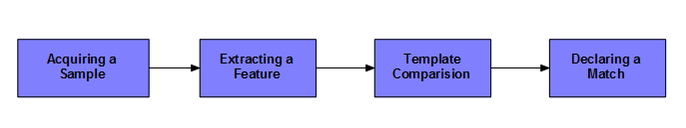

**3.3.1 Acquiring a sample:** In a complete, full implemented biometric system, a sensor takes an observation. The sensor might be a camera and the observation is a snapshot picture. In our system, a sensor will be ignored, and a 2D face picture “observation” will supplied manual

5

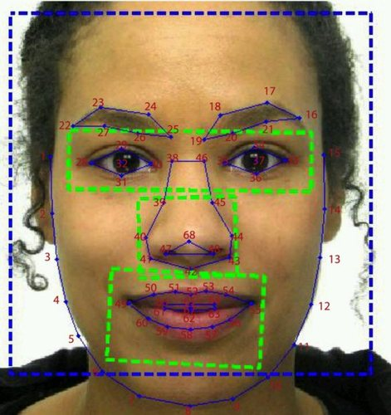

**Fig 3.3.1: Acquiring a sample**

**3.3.2 Extracting Features:** For this step, the relevant data is extracted from the predefined captured sample. This is can be done by the use of software where many algorithms are available. The outcome of this step is a biometric template which is a reduced set of data that represents the unique features of the enrolled user's face.

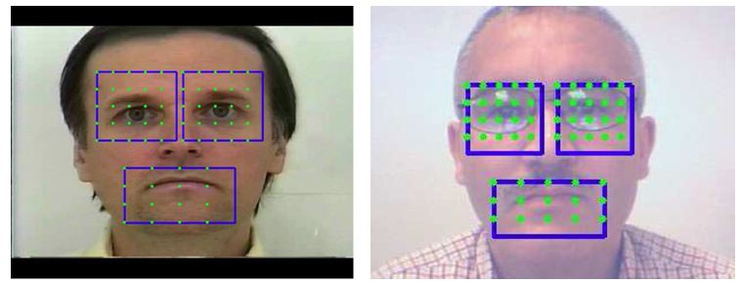

**Fig 3.3.2: Extracting Features**

**3.3.3 Comparison Templates:** This depends on the application at hand. For identification purposes, this step will be a comparison between a given picture for the subject and all the biometric templates stored on a database. For verification, the biometric template of the claimed identity will be retrieved (either from a database or a storage medium presented by the subject) and this will be compared to a given picture.

**3.3.4 Declaring a Match:** The face recognition system will return a candidate match out of potential matches.

6

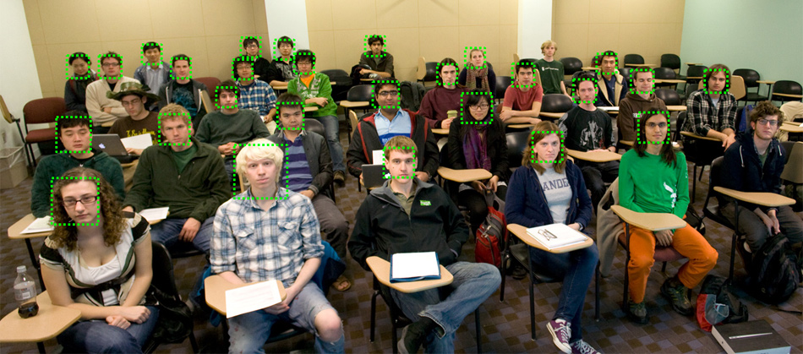

**Fig 3.3.3: Declaring a Match**

* This code is supposed to grab live camera feed, display feed in a window, mark in rectangles all detected faces, get the biggest detected face (by total area), display it in separate window, convert it to grayscale and finally save as BMP to hard disk, in project directory
* It is a fast, accurate and reliable than any other existing method.
* Face recognition is easy to use and in many cases it can be performed without person even knowing.
* Face recognition is also one of the most inexpensive biometric in the market and its price should continue to go down.
* There are many benefits to face recognition system such as its convenience and social acceptability

7

**CHAPTER-4**

**PROBLEM DEFINITION**

**PROBLEM DEFINITION**

Every time the lecture starts, taking attendance manually becomes a lengthy process and takes a lot of time and effort, especially if it is a lecture with a huge number of students. It also causes a lot of disturbance and interruption during lectures. Moreover the attendance sheet is subjected to damage and loss while being passed on between different students or teaching staff. And when the number of students enrolled in a certain course is huge then the time required for manual attendance increases. Finally, these attendance records are used by the staff to monitor the students’ attendance rates. This process could be easy and effective with a small number of students but on the other hand, dealing with the records of a large number of students often leads to human errors.

8

**CHAPTER-5**

**PROPOSED SYSTEM**

**PROPOSED SYSTEM**

The Proposed system overcomes the problem of the existing system. This project uses the face recognition technique using this student record the attendance.

In the proposed system when student come to the class or lecture system application is start.

It works only when the student is standing in front of the system (Computer application) the application capture the image and send the image to the processing side.

The processing side recognize the face of the student.

Finally the application mark the attendance of student as present. If the face is not recognizing the application make as absent.

9

**CHAPTER-6**

**REQUIRMENTS**

**REQUIREMENTS**

* HARDWARE REQUIRMENT

1. Processing: 1.66 GHz Pentium Processor or Intel compatible processor.
2. Memory: 2GB RAM
3. 80 GB free Hard Disk space
4. Web camera of Resolution: 512 by 512 pixels.

* SOFTWARE REQUIRMENT1. Visual Studio 2010 (.net framework)

2. My SQL Server 2008

10

**CHAPTER-7**

**BLOCK DIAGRAM**

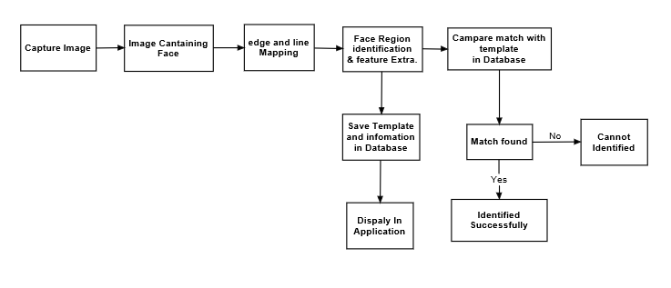**BLOCK DIAGRAM**

**Step1:** Acquiring a sample in a complete, full implemented biometric system, a sensor takes an observation. The sensor might be a camera and the observation is a snapshot picture.

**Step2**: Extracting features for this step, the relevant data is extracted from the predefined captured sample. This is can be done by the use of software where many algorithms are available.

**Step3:** Comparison templates this depends on the application at hand. For identification purposes, this step will be a comparison between a given picture for the subject and all the biometric templates stored on a database.

**Step4:** Declaring a Matchthe face recognition system will return a candidate match list of potential matches. In this case, the intervention of a human operator will be required in order to select the best fit from the candidate list.

11

**CHAPTER-8**

**DATA FLOW DIAGRAM (DFD):**

**DATA FLOW DIAGRAM**

**8.1 LEVEL 0 DFD**

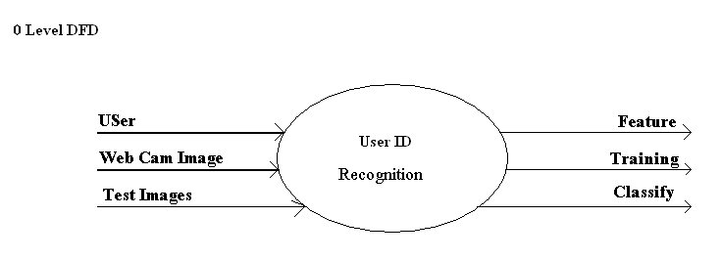Fig8.1:DFD Level 0

**8.2 Level 1 DFD**

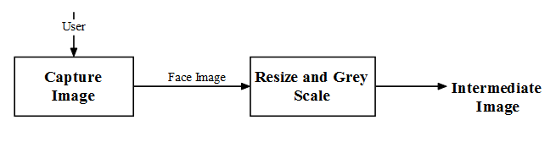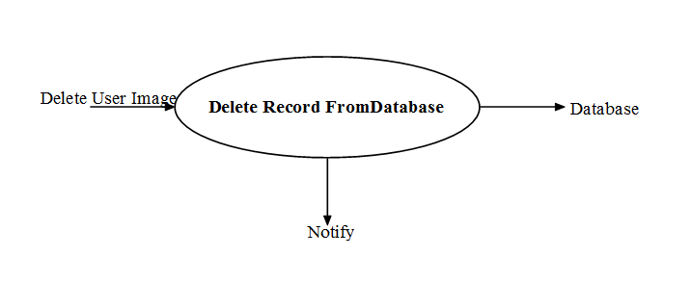

12

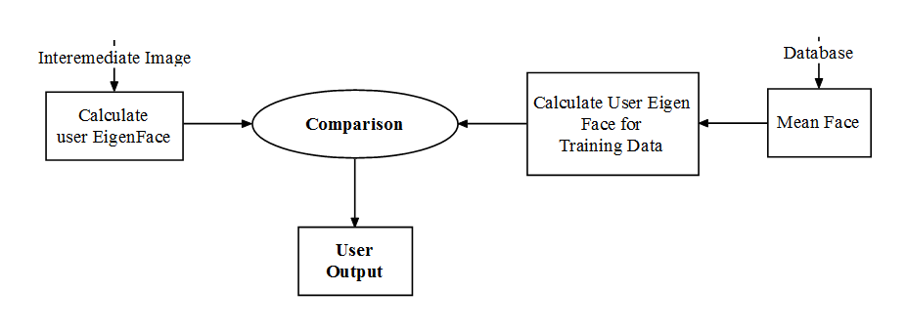

Fig 8.2: DFD Level 1

**8.3 Level 2 DFD**

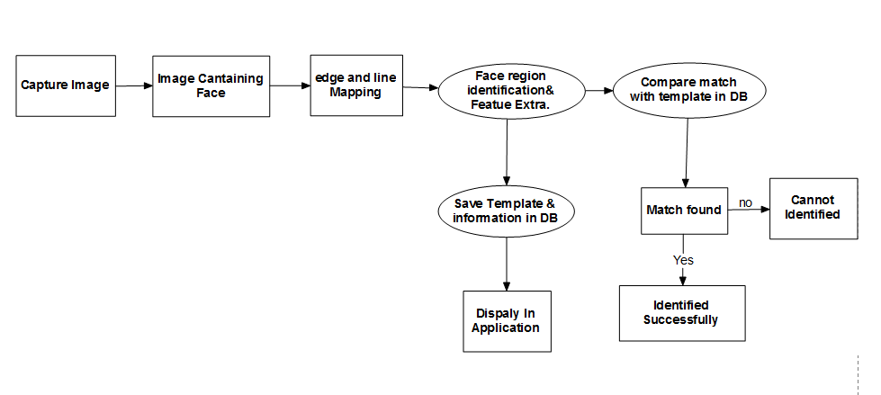Fig 8.3: DFD Level 2

13

**CHAPTER-9**

**SEQUENCE DIAGRAM**

**SEQUENCE DIAGRAM**

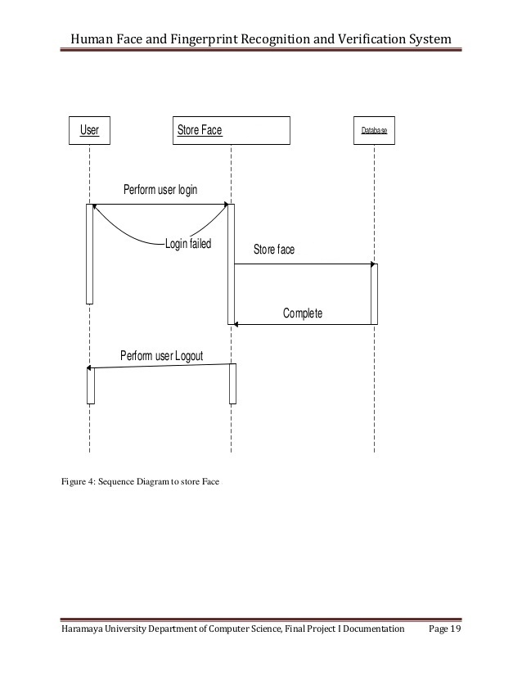

Fig:9.1: Sequence Diagram to store Face

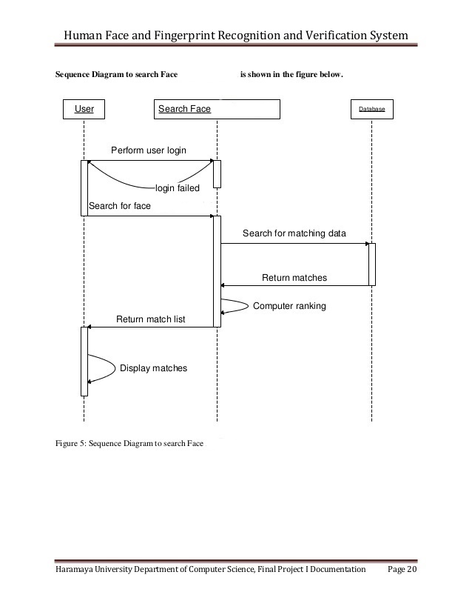

Fig:9.2: Sequence Diagram to search face

14

**CHAPTER-10**

**ACTIVITY DIAGRAM**

**ACTIVITY DIAGRAM**

Activity Diagram is used to Document the logic of a single operation/ methods, a single use case, or the flow of logic of a business operation. In many ways Activity Diagrams are the object oriented Equivalent of flow chart and Data flow Diagram from Structure development

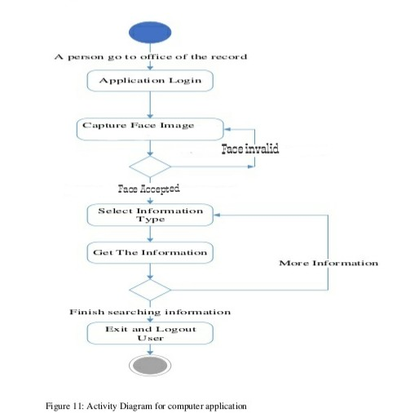

Fig. Activity Diagram for complete Diagram

15

**CHAPTER-11**

**UML DIAGRAMS**

**UML DIAGRAMS**

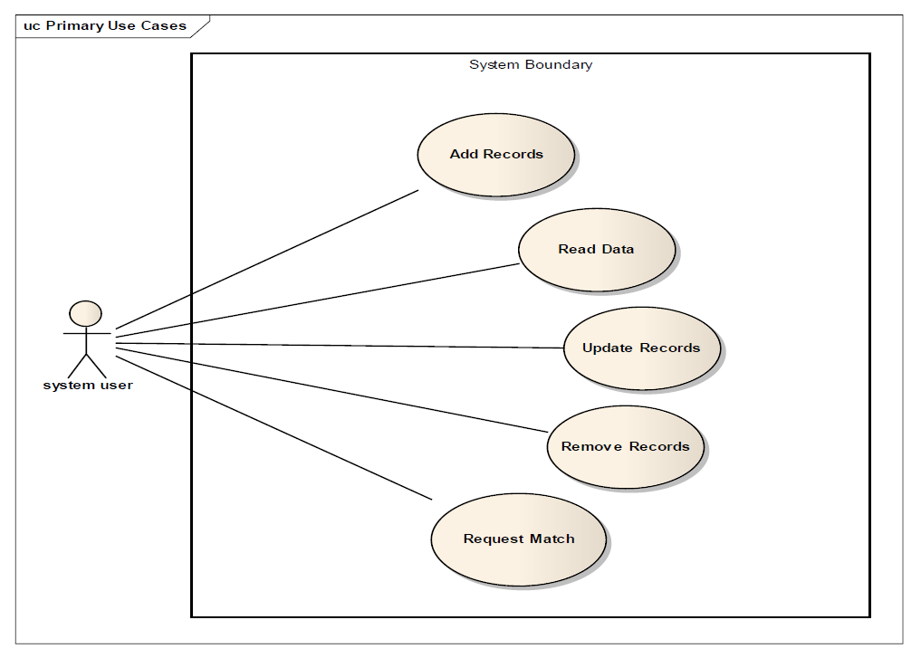

16

**CHAPTER-12**

**IMPLEMENTATION**

**IMPLEMENTATIONS**

The proposed system plan for an Automatic Attendance System using image processing includes:

>Enrollment of students.

>Capturing the video of students.

>Face detection and feature extraction.

>Face recognition and marketing attendance.

17

**CHAPTER-13**

**UNIQUENESS OF THE TOPIC**

**UNIQUENESS OF THE TOPIC**

This project serves to automate the prevalent traditional tedious and time wasting methods of marking student attendance in classrooms. The use of automatic attendance through face detection and recognition will increase the effectiveness of attendance monitoring and management.

This method could also be extended for use in examination halls to curb cases of impersonation as the system can also be updated which will be able to single out the imposters who won’t have been captured during the enrollment process. Applications of face recognition are widely spreading in areas such as criminal identification, security systems, image and film processing. The system could also find applications in all authorized access facilities.

18

**CHAPTER-14**

**MERITS AND DEMERITS**

**MERITS AND DEMERITS**

* **MERITS**

1. Improved security
2. Improved customer experience
3. Cannot be forgotten or lost
4. Reduced operational costs

* **DEMERITS**

1. Environment and usage can affect measurements
2. Systems are not 100% accurate.
3. Require integration and/or additional hardware
4. Cannot be reset once compromised

19

**CHAPTER-15**

**SCREENSHOTS**

**SCREENSHOTS** 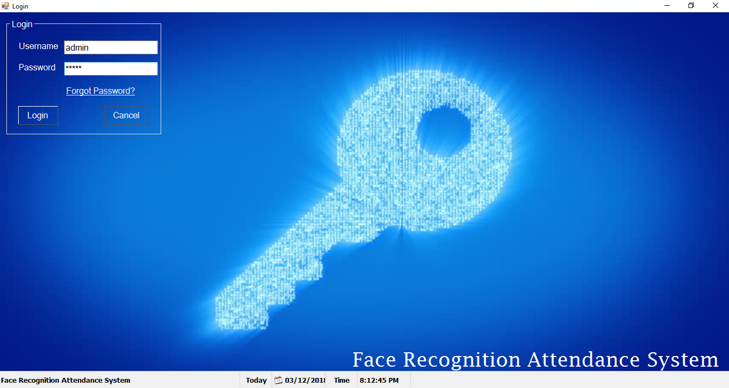

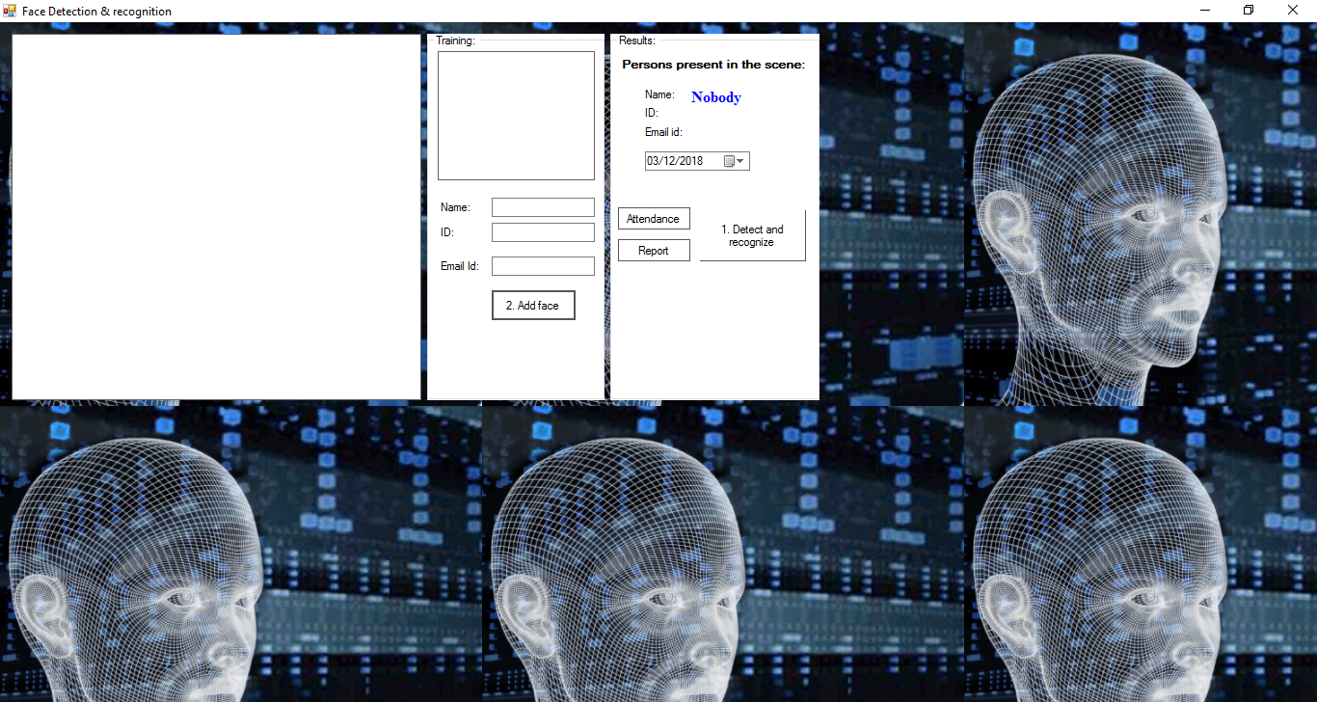 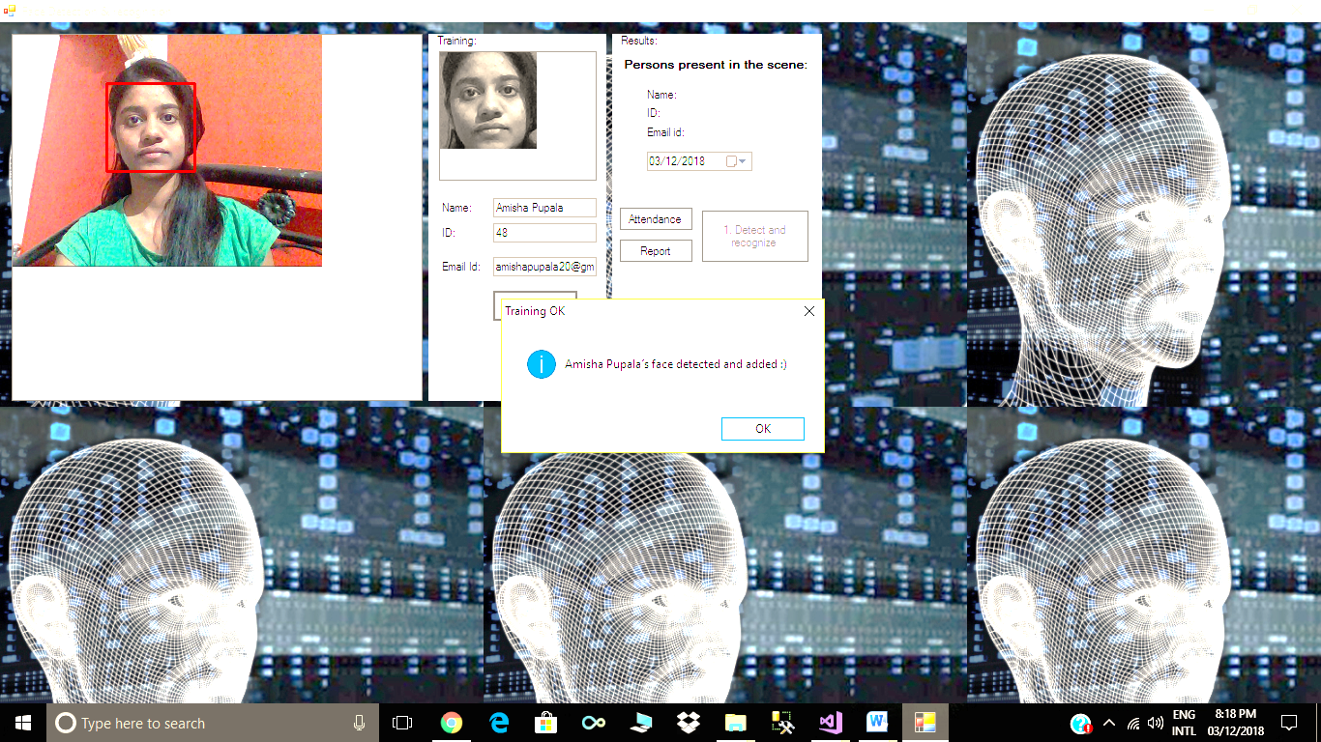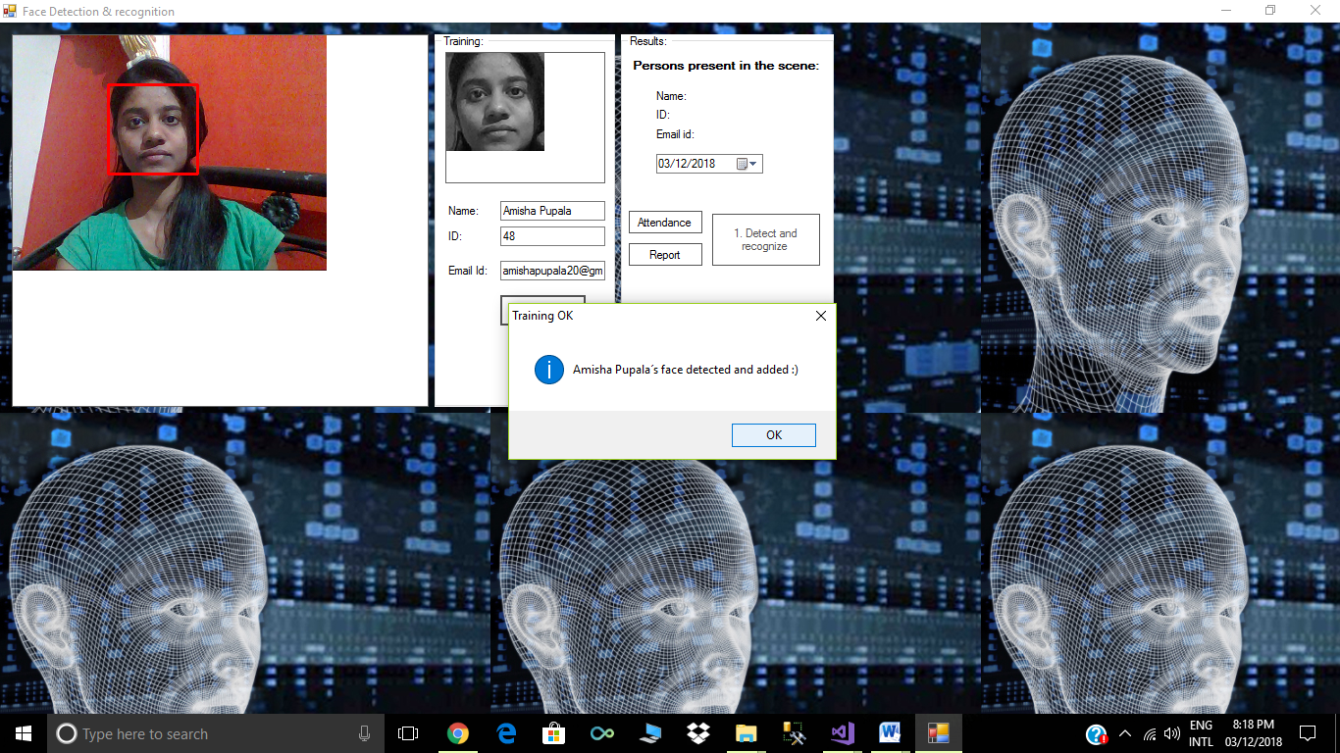 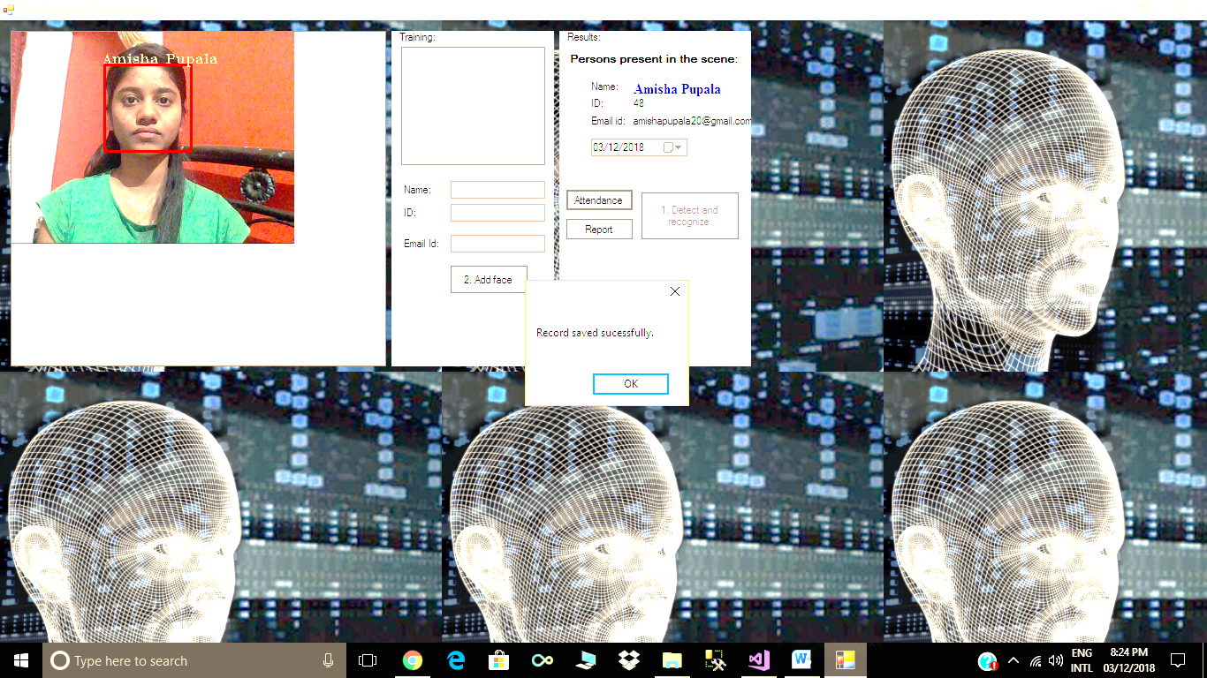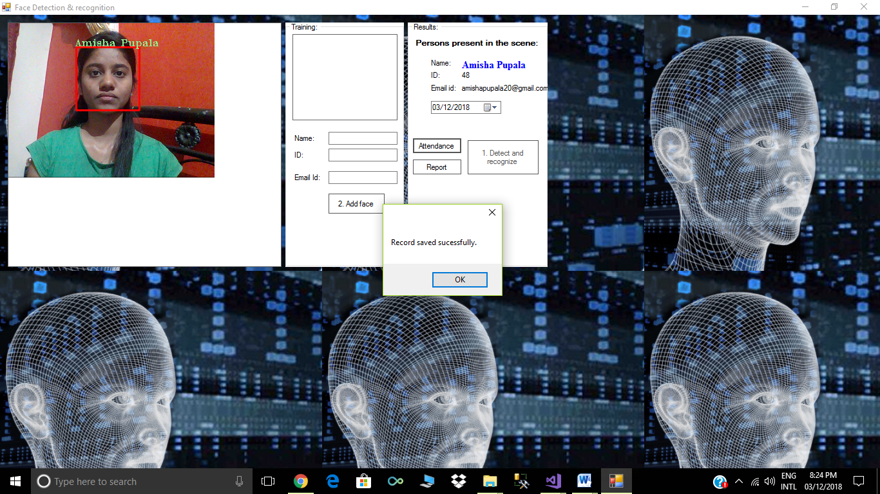

20

21

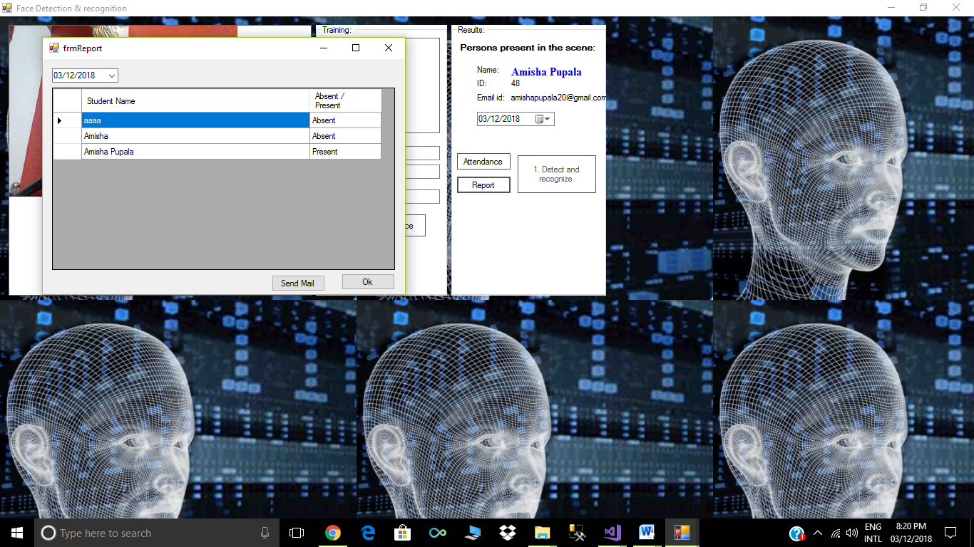

22

**CHAPTER-16**

**CONCLUSION**

**CONCLUSION**

It can be concluded from the above dialogue that a dependable, secure, rapid and an efficient system has been evolved changing a guide and an unreliable system. This process can be carried out for higher outcomes regarding the control of attendance. This system will keep time, reduce the quantity of work the administration has to do and will update stationary material with digital apparatus .Every other application of this machine is that it is capable of marking the presence of personnel at any place of work and this attendance will be useful for calculating their month to month payment.

23

**CHAPTER-17**

**FUTURE SCOPE**

**FUTURE SCOPE**

The system we have developed has successfully able to accomplish the task of making the attendance in the classroom automatically and output can be obtained in an excel sheet as desired in real time. Another important aspect where we can work is towards creating an online data base of the attendance and its automatic updating, keeping in mind growing popularity of internet of things. The scope of the project is the system on which the software is installed, i.e. the project is developed as a desktop application, and it will work for a particular institute. But later on the project can be modified to operate it online. Face recognition systems used today work very well under constrained conditions, although all systems work much better with frontal mug-shot images and constant lighting. All current face recognition algorithms fail under the vastly varying conditions under which humans need to and are able to identify other people. Next generation person recognition systems will need to recognize people in real-time and in much less constrained situations.

24

**CHAPTER-18**

**REFERENCE**

**REFERENCE**

Sites referred for the project are as follows:

<https://mail.google.com/mail/u/0/#inbox/15e815608ba639d6?projector=1>

<https://www.researchgate.net/profile/Tetsuo_Shoji2/publication/241608617_Face_Recognition-based_Lecture_Attendance_System/links/54418ff00cf2a76a3cc82282/Face-Recognition-based-Lecture-Attendance-System.pdf>

https://www.quora.com/What-are-techniques-used-for-facial-recognition-and-image-processing

<https://www.ncbi.nlm.nih.gov/pubmed/8027706>

Books referred for the project are as follows :

* W. Zhao, R. Chellappa, P. J. Phillips, and A. Rosenfeld,“Face recognition: A literature survey,” ACM Computing Surveys, 2003, vol. 35, no. 4, pp. 399-458.
* Herbert Bay, Andreas Ess, TinneTuytelaars, and Luc Van Gool. Surf: Speeded up robust features. Computer Vision and Image Understanding (CVIU), 110(3):346–359.
* H.K.Ekenel and R.Stiefelhagen,Analysis of local appearance based face recognition: Effects of feature selection and feature normalization. In CVPR Biometrics Workshop, New York, USA, 2016

25

**ACKNOWLEDGEMENT**

Working on this project on “Face Recognition Attendance System” was a source of immense knowledge to us. It’s a great pleasure and moment of immense satisfaction for us to express our profound gratitude to our guide **Prof. Mayur Bhosale,** whose constant encouragement enabled us to work enthusiastically. His perpetual motivation, patience and excellent expertise in the discussion during progress of the project work have benefited us to an extent, which is beyond expression. We would also like to give our sincere thanks to **Prof. Umesh Patil**, **Head of** **Department,** from DepartmentComputer Engineering**,** Dr. D.Y. Patil Polytechnic, Nerul, Navi Mumbai for his guidance, encouragement and support during the seminar. We are also thankful to **Prof. S. G. Pathak, Principal**, Dr. D.Y. Patil Polytechnic, Nerul, Navi Mumbai for providing an outstanding academic environment, also for providing the adequate facilities. We acknowledge with a deep sense of gratitude, the encouragement and inspiration received from our faculty members and colleagues.

26